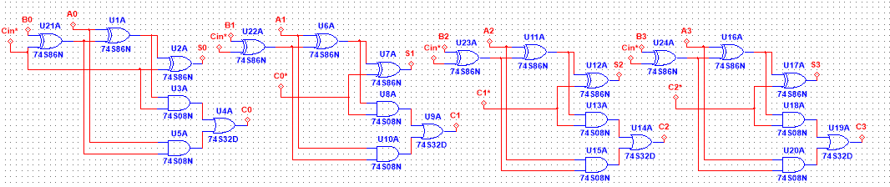

Required circuit

Circuit breakdown :

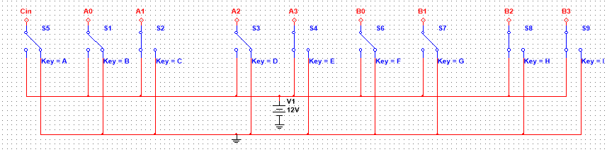

Inputs of 4 bit ALU

When the switch turns to ground the outputs becomes 0,then:

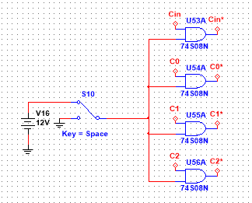1)Cin\* becomes 0 ,which means the circuit behaves as adder.

2)Input carry of every full adder becomes zero.

3)The output of every adder summation,carry becomes XOR and AND of the input bits.

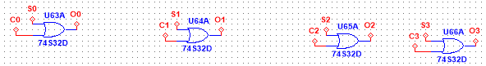

4) OR of AND and XOR gates of bits A,B becomes OR of A and B.

Display:

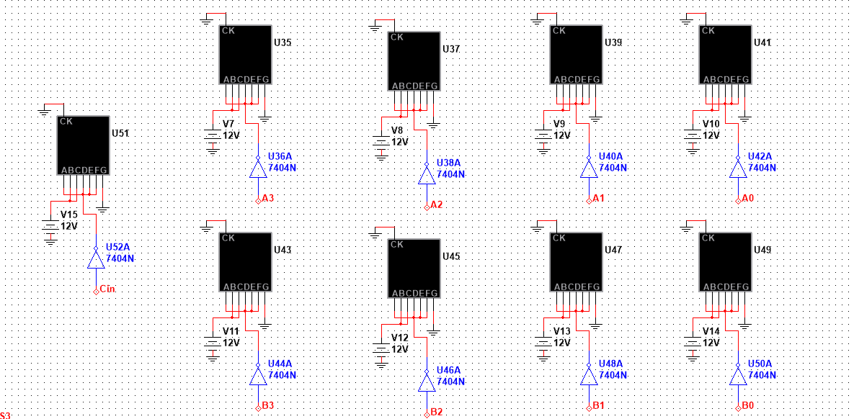

4 bit inputs along with input carry. 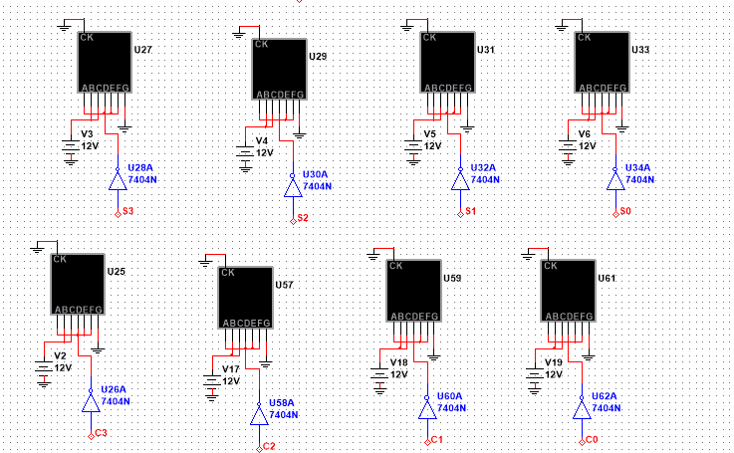

1)S and C represent summation and carry if Cin\*=0 and difference and borrow if Cin\*=1.

2)S and C represent XOR and AND if S10 is turned to ground.

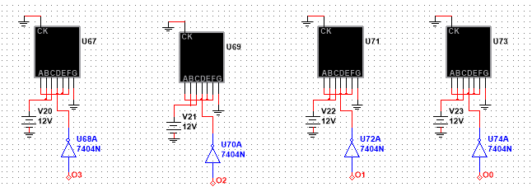

O is the OR of inputs A and B if S10 is turned to ground.